**Requirements Document**

A small local bank intends to install a new automated teller machine (ATM) to allow users

(i.e., bank customers) to perform basic financial transactions (Fig. 3.28). For simplicity, each user can have only one account at the bank. ATM users should be able to view their account balance, withdraw cash (i.e., take money out of an account) and deposit funds (i.e., place money into an account).

The user interface of the automated teller machine contains the following hardware components:

**• A screen that displays messages to the user**

**• A keypad that receives numeric input from the user**

**• A cash dispenser that dispenses cash to the user**

**• A deposit slot that receives deposit envelopes from the user**

The cash dispenser begins each day loaded with 500 $20 bills.

[***Note****:* Owing to the limited scope of this case study, certain elements of the ATM described here simplify various aspects of a real ATM. For example, a real ATM typically contains a device that reads a user’s account number from an ATM card, whereas this ATM asks the user to type an account number on the keypad (which you will simulate with your computer’s keypad).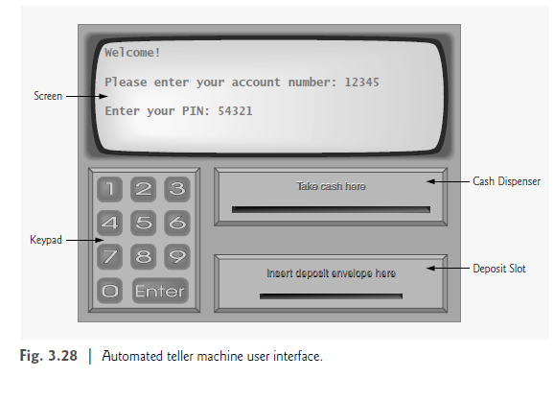

Also, a real ATM usually prints a paper receipt at the end of a session, but all output from

this ATM appears on the screen.]

The bank wants you to develop software to perform the financial transactions initiated

by bank customers through the ATM. The bank will integrate the software with the ATM’s hardware at a later time. The software should simulate the functionality of the hardware devices (e.g., cash dispenser, deposit slot) in software components, but it need not concern itself with how these devices perform their duties. The ATM hardware has not been developed yet, so instead of writing your software to run on the ATM, you should develop a first version of the software to run on a personal computer. This version should use the computer’s monitor to simulate the ATM’s screen and the computer’s keyboard to simulate the ATM’s keypad.

An ATM session consists of authenticating a user (i.e., proving the user’s identity) based on an account number and personal identification number (PIN), followed by creating and executing financial transactions. To authenticate a user and perform transactions, the ATM must interact with the bank’s account information database. [Note: A database is an organized collection of data stored on a computer.] For each bank account, the database stores an account number, a PIN and a balance indicating the amount of money in the account.

**Upon approaching the ATM, the user should experience the following sequence of events** **(see Fig. 3.28):**

1. The screen displays a welcome message and prompts the user to enter an account number.

2. The user enters a five-digit account number, using the keypad.

3. For authentication purposes, the screen prompts the user to enter the PIN (personal identification number) associated with the specified account number.

4. The user enters a five-digit PIN, using the keypad.

5. If the user enters a valid account number and the correct PIN for that account,

the screen displays the main menu **(Fig. 3.29).** If the user enters an invalid account

number or an incorrect PIN, the screen displays an appropriate message,

then the ATM returns to Step 1 to restart the authentication process.

After the ATM authenticates the user, the main menu (Fig. 3.29) displays a numbered

option for each of the three types of transactions:

balance inquiry (option 1), withdrawal(option 2) and deposit (option 3).

The main menu also displays an option that allows the user to exit the system (option 4).

The user then chooses either to perform a transaction (by entering 1, 2 or 3) or to exit the system (by entering 4). If the user enters an invalid option, the screen displays an error message, then redisplays the main menu.

**If the user enters 1 to make a balance inquiry**, the screen displays the user’s account

balance. To do so, the ATM must retrieve the balance from the bank’s database.

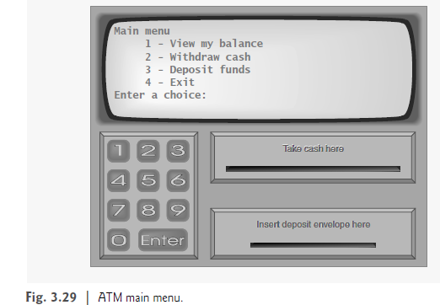

**The following actions occur when the user enters 2 to make a withdrawal:**

1. The screen displays a menu **(shown in Fig. 3.30)** containing standard withdrawal

amounts: $20 (option 1), $40 (option 2), $60 (option 3), $100 (option 4) and

$200 (option 5). The menu also contains option 6 that allows the user to cancel

the transaction.

2. The user enters a menu selection (1–6) using the keypad.

3. If the withdrawal amount chosen is greater than the user’s account balance, the

screen displays a message stating this and telling the user to choose a smaller

amount. The ATM then returns to Step 1. If the withdrawal amount chosen is

less than or equal to the user’s account balance (i.e., an acceptable withdrawal

amount), the ATM proceeds to Step 4. If the user chooses to cancel the transaction

(option 6), the ATM displays the **main menu (Fig. 3.29**) and waits for user

input.

4. If the cash dispenser contains enough cash to satisfy the request, the ATM proceeds

to Step 5. Otherwise, the screen displays a message indicating the problem

and telling the user to choose a smaller withdrawal amount. The ATM then returns

to Step 1.

5. The ATM debits (i.e., subtracts) the withdrawal amount from the user’s account

balance in the bank’s database.

6. The cash dispenser dispenses the desired amount of money to the user.

7. The screen displays a message reminding the user to take the money.

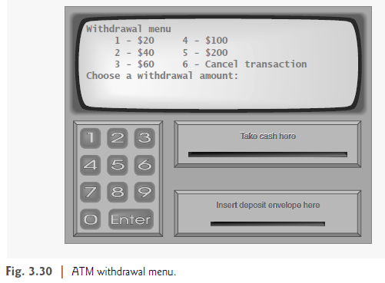

**The following actions occur when the user enters 3 (from the main menu) to make a**

**deposit:**

1. The screen prompts the user to enter a deposit amount or to type 0 (zero) to cancel

the transaction.

2. The user enters a deposit amount or 0, using the keypad. [Note: The keypad does

not contain a decimal point or a dollar sign, so the user cannot type a real dollar

amount (e.g., $147.25). Instead, the user must enter a deposit amount as a number

of cents (e.g., 14725). The ATM then divides this number by 100 to obtain

a number representing a dollar amount (e.g., 14725 ÷ 100 = 147.25).]

3. If the user specifies a deposit amount, the ATM proceeds to Step 4. If the user

chooses to cancel the transaction (by entering 0), the ATM displays the main

menu (Fig. 3.29) and waits for user input.

4. The screen displays a message telling the user to insert a deposit envelope into the

deposit slot.

5. If the deposit slot receives a deposit envelope within two minutes, the ATM credits

(i.e., adds) the deposit amount to the user’s account balance in the bank’s database.

If the deposit slot does not receive a deposit envelope within two minutes, the screen displays a message that the system has canceled the transaction due to inactivity. The ATM then displays the main

menu and waits for user input.

After the system successfully executes a transaction, the system should redisplay the

main menu (Fig. 3.29) so that the user can perform additional transactions. If the user

chooses to exit the system (by entering option 4), the screen should display a thank you

message, then display the welcome message for the next user.